To create a database write

Create database django

To select the database write use django

Create a table

create table books(bookid int auto_increment primary key, bookname varchar(100) not null,price int not null check(price>0))

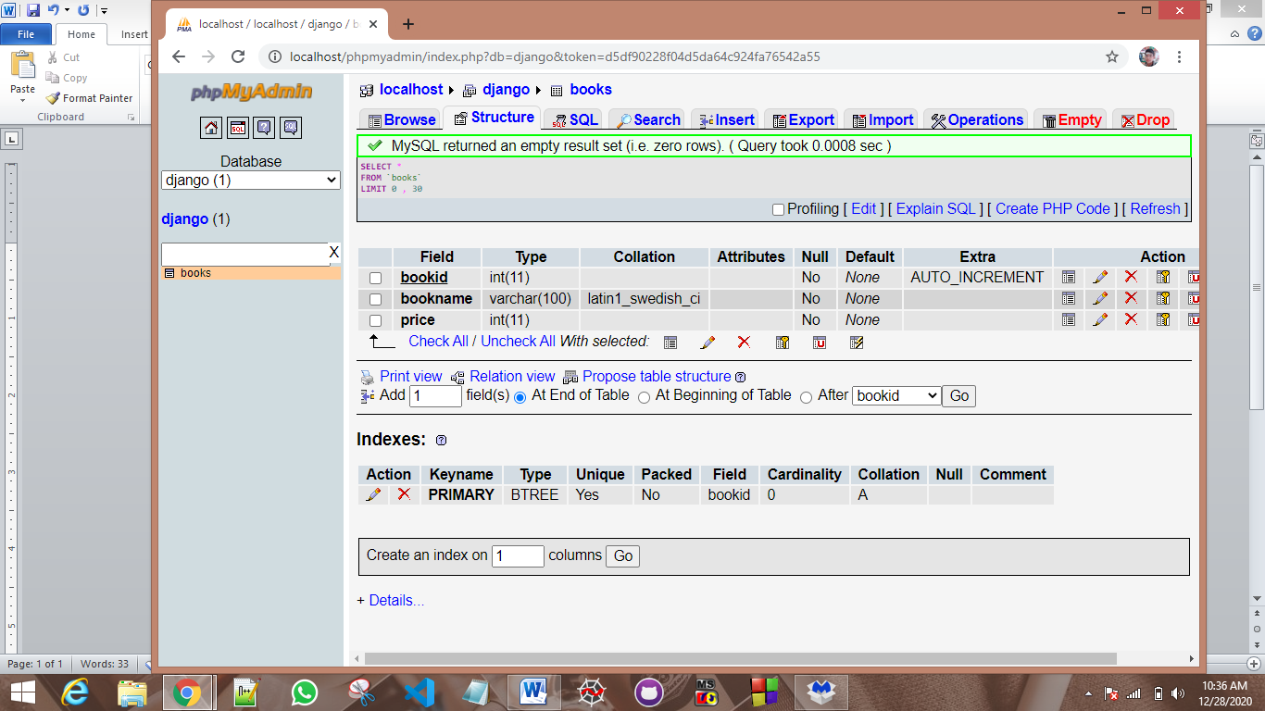

To insert

insert into books values(NULL,'Basic C','100')

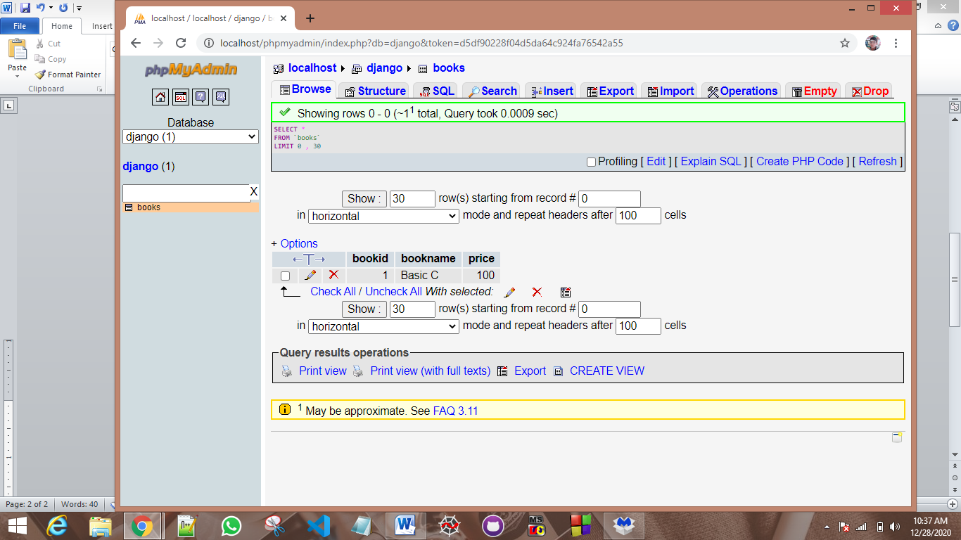

Select

select * from books where bookname='Basic C'

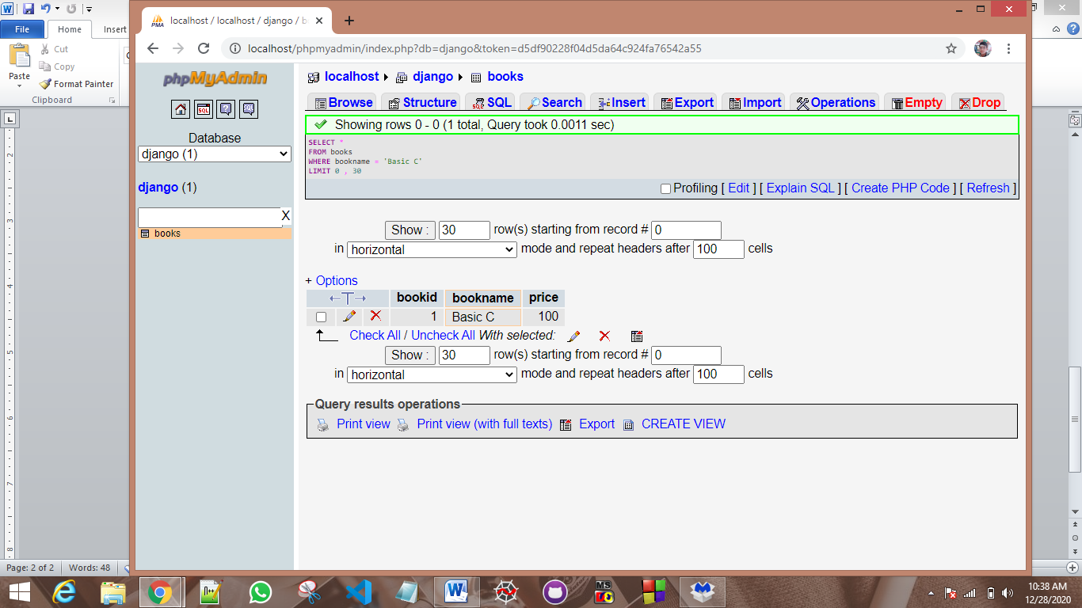

Update

update books set price=price+10 where bookname='Basic C'

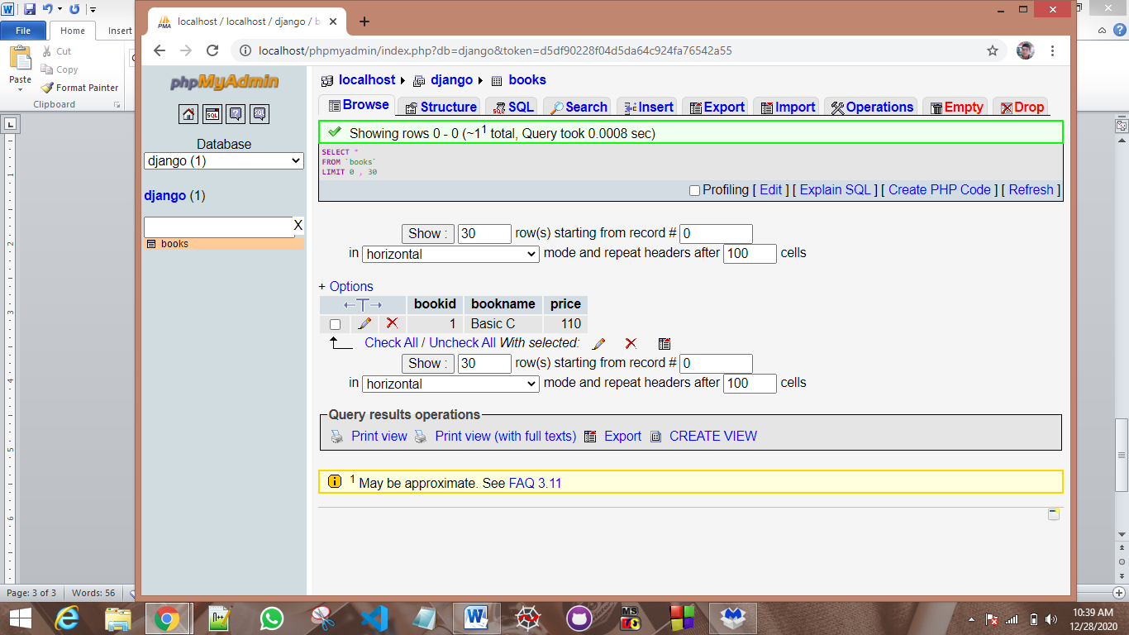

Delete

delete from books where bookname='Basic C'

